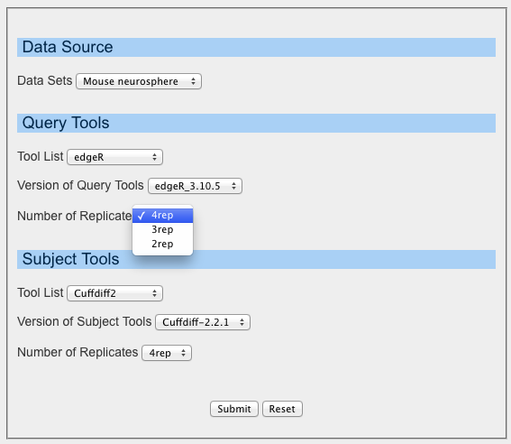
Supplementary Figure 1. The user input options of DEAR-O include choice of data source, choice of analysis tools and their versions, and choice of the number of biological replicates used in the analysis.

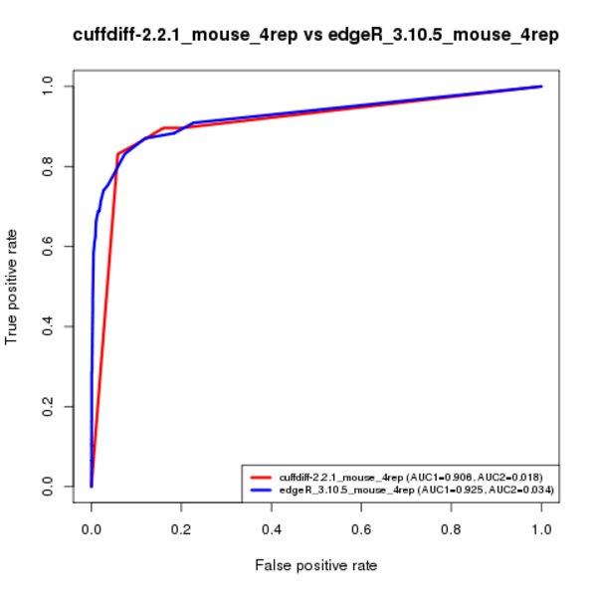
Supplementary Figure 2. The ROC curve with two AUC values to show the comparative results between the query and subjects sets.
(i) AUC1 is the area under the ROC curve in the full range of FPR (i.e. 0≤FPR≤1).
(ii) AUC2 is the area under the ROC curve in the range of 0≤FPR≤0.05.

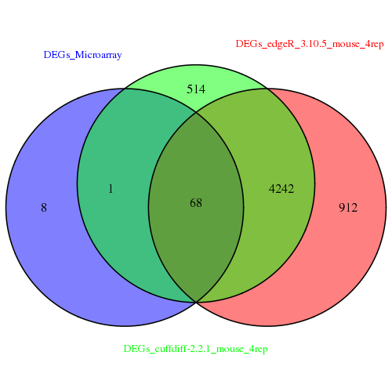
Supplementary Figure 3. Venn diagram to show the intersections of the number of DEGs identified by the query and subject sets with the gold standard set.

Supplementary Table 1. The sensitivity and specificity of the query and subject sets.
Software | Specificity | Sensitivity
edgeR_3.10.5_4rep | 0.816 | 0.883
cuffdiff-2.2.1_4rep | 0.840 | 0.896

Supplementary Table 2. The number of DEGs from the query set, the subject set and the gold standard set.
Methods | Number of DEGs
edgeR_3.10.5_4rep | 5222
cuffdiff-2.2.1_4rep | 4825
Microarray | 77

