SUPPLEMENTAL FILES
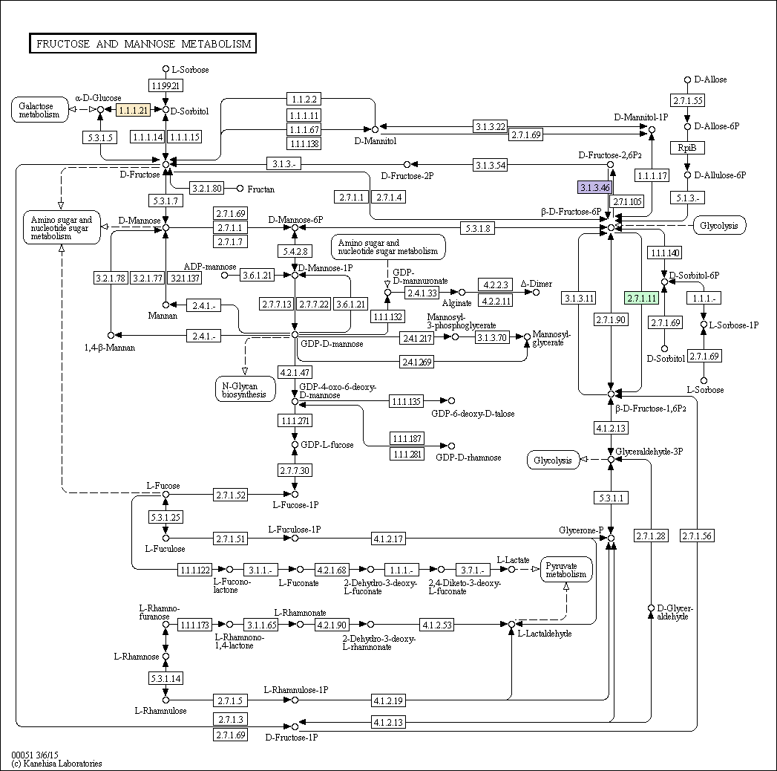
Supplemental Figure S.1 KEGG analysis for biochemical pathways that contain multiple outlier contigs. Colored boxes represent outlier genes.
